1. Use the database ‘SQL1_NORMAL’.

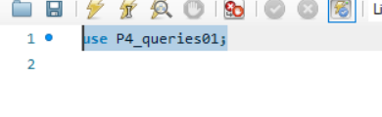

2. Begin a transaction (also set autocommit to off before beginning the transaction).

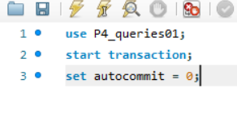

3. Query the average commission of the employees.

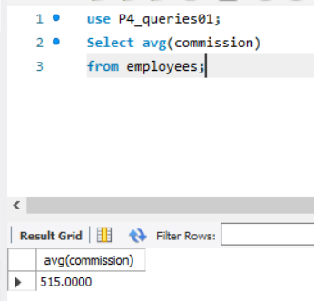

4. Increase employees’ commission by 20%.

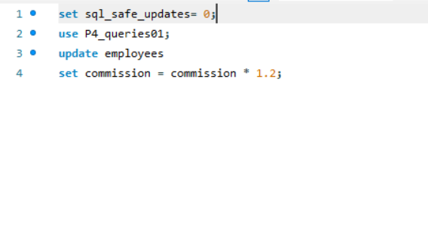

5. Query again the average commission of the employees. Is it higher?

Sí

6. Delete the employees with surname “TOVAR”.

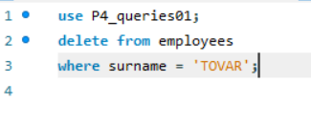

7. Rollback all the operations.

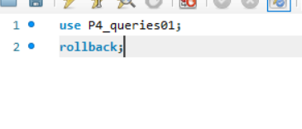

8. Query again the average commission of the employees and check if there are employees with surname “TOVAR”.

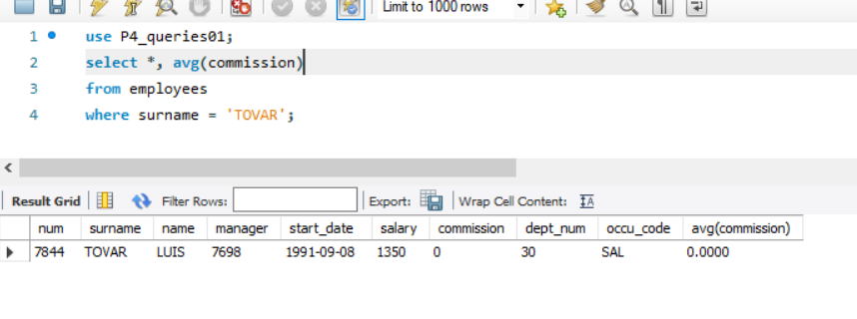

9. Create a savepoint with name “SPINCCOMMISSION”

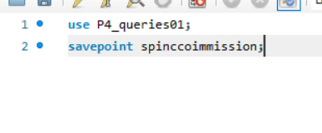

10. Increase employees’ commission by 20%.

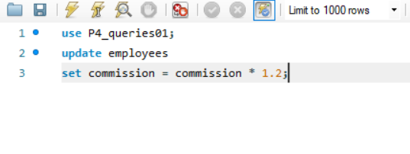

11. Query again the average commission of the employees. is it higher?

No.

12. Create a savepoint with name “SPDELTOVAR”.

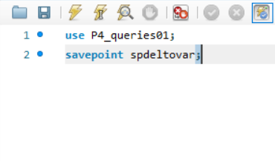

13. Delete the employees with surname “TOVAR”.

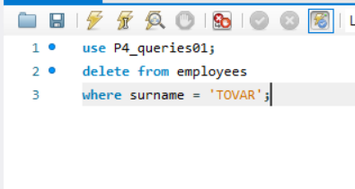

14. Rollback to savepoint “SPDELTOVAR”.

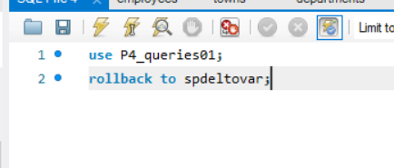

15. Query again the average commission of the employees and check if there are employees with surname “TOVAR”.

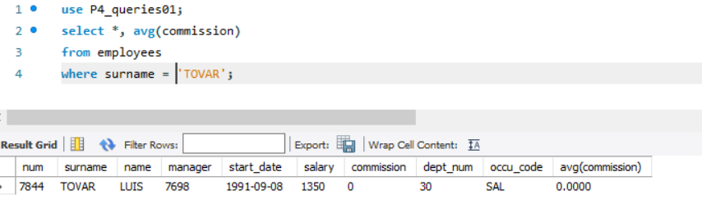

16. Commit all the operations.

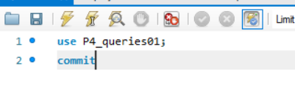

17. Do employees with surname “TOVAR” exist or not? Is the commission increased?

Sí existe y la comisión está incrementada.